**Acids and Bases Web-quest**

Go to each of the websites, complete the activities or answer the questions.

**Site 1:** <http://www.visionlearning.com/library/module_viewer.php?mid=58>

1. Describe the physical properties of acids.
2. Describe the physical properties of bases.
3. What is neutralisation?
4. Give 4 examples of acids and 4 examples of bases from the pH scale on the site.

|  |  |
| --- | --- |
| Examples of Acids | Examples of Bases |
|  |  |
|  |  |
|  |  |
|  |  |

**Site 2:** https://phet.colorado.edu/sims/html/ph-scale-basics/latest/ph-scale-basics_en.html

1. Using the simulation, measure the pH of each substance, and classify each one as an acid or a base.

|  |  |  |  |  |  |
| --- | --- | --- | --- | --- | --- |
| **Substance** | **pH** | **Acid or Base?** | **Substance** | **pH** | **Acid or Base?** |
|  |  |  |  |  |  |
|  |  |  |  |  |  |
|  |  |  |  |  |  |
|  |  |  |  |  |  |
|  |  |  |  |  |  |
|  |  |  |  |  |  |

1. Half fill the tank in the simulation with an **acid** of your choice. Fill the rest of the tank with water. What happens to the pH of the acid as you add water?
2. Half fill the tank in the simulation with a **base** of your choice. Fill the rest of the tank with water. What happens to the pH of the base as you add water?

**Site 3:** <http://www.harcourtschool.com/activity/acids>

Click on each of the test tubes to test the pH. Use the test results to complete the table.

|  |  |  |  |  |
| --- | --- | --- | --- | --- |
| **Test Tube** | **Indicator Paper Colour** | **pH** | **Acid or Base?** | **Substance** |
| 1 |  |  |  |  |
| 2 |  |  |  |  |
| 3 |  |  |  |  |
| 4 |  |  |  |  |
| 5 |  |  |  |  |

**Site 4:** <https://www.news-medical.net/health/pH-in-the-Human-Body.aspx>

1. 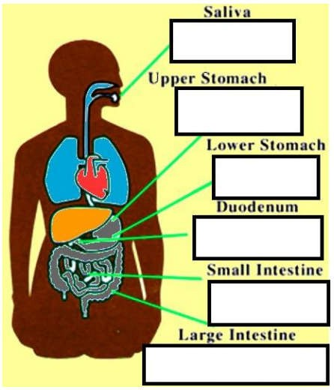Track the pH as you move through the digestive system.
2. Why is it important to maintain constant pH levels in the digestive system?

**Site 5:** <http://education.abc.net.au/res/i/L5814/index.html>

Fill in the table after investigating the three different substances.

|  |  |  |
| --- | --- | --- |
| Hydrochloric acid | Water | Limewater |
|  |  |  |

**Site 6:** https://static.lawrencehallofscience.org/scienceview/scienceview.berkeley.edu/html/showcase/flash/juicebar.html

Complete the three challenges.

**Site 7:**  https://tn.pbslearningmedia.org/resource/kqedq11.sci.acidicseas/acidic-seas/

Watch the video on the website or access it via connect.

1. What causes acidity in the oceans?
2. How has ocean acidity changed over time?
3. What is causing ocean acidification?
4. What kinds of marine life are negatively affected by an increase in ocean acidity levels?
5. How are these marine organisms affected?
6. What do you think can be done to change the pH level in our oceans?